**MAHATMA GANDHI**

**Mahatma Gandhi was a lawyer, politician and thinker Indian nineteenth and early twentieth century (born October 2, 1869 and was assassinated on January 30, 1948) known for claim and lead the Indian independence through nonviolent methods.**

**His mother was one of his most important influences in life, because she learned respect for living things, the virtues of vegetarianism and tolerance for different ways of thinking, even to other faiths and religions.**

**In his relations and his inevitable clashes with government authorities of South Africa it opened a better way of controlling, or resistance that kept the respect for the human person and prevented armed revolt.**

**Many and varied were his humanitarian efforts; He instituted agricultural colonies and hospitals, and especially since, tried to eliminate the castes and religions that divided his people.**

**Gandhi was a leader and teacher of his people and has led to the achievement of the goal he had dreamed ardently. Gandhi saw independent India.**

**On January 30, 1948, Gandhi was assassinated by Nathuram Godse, an ultra-right-wing Hindu fanatic associated with the government; Gandhi found an obstacle to lift your project the uprising of Hinduism to the detriment of other beliefs and religions.**

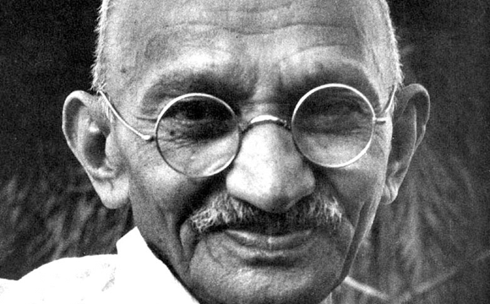

**NAMES:**

* **Andrea Catalina Reyes Montoya.**
* **Laura Juliana Reyes Montoya.**